H.T No
Regulations:
A20

Sreenidhi Institute of Science and Technology
(An Autonomous Institution)
Code No:8FC05 Date: 08-Aug-2024 (AN)

B.Tech III-Year I- Semester External Examination, August-2024 (Supplementary)
DESIGN AND ANALYSIS OF ALGORITHMS (ECM and CS)

Time: 3 Hours Max.Marks:70

Note: a) No additional answer sheets will be provided.
b) All sub-parts of a question must be answered at one place only, otherwise it will not be valued.
c) Missing data can be assumed suitably.

Bloom's Cognitive Levels of Learning (BCLL)

Remember | L1 | Apply | L3 | Evaluate | L5
Understand | L2 | Analyze | L4 | Create | L6

Part - A Max.Marks:20
Answer all QUESTIONS

 |  | BCLL | CO(s) | Marks
1 | Define environmental stack space. | L1 | CO1 | [2M]
2 | Write the control abstraction of Divide and Conquer technique. | L1 | CO2 | [2M]
3 | Define Optimal Solution. Give an example. | L1 | CO3 | [2M]
4 | What is the importance of reliability design in Hardware manufacture? | L2 | CO4 | [2M]
5 | Write the applications of backtracking. | L1 | CO5 | [2M]
6 | Write an example function for Non-deterministic search. | L1 | CO6 | [2M]
7 | Define Omega Notation. | L1 | CO1 | [2M]
8 | Write any two applications of Dynamic Programming. | L1 | CO3 | [2M]
9 | Define tractable and intractable problems. | L1 | CO5 | [2M]
10 | Is Strassen’s matrix multiplication is better than traditional matrix multiplication? Justify your answer. | L2 | CO6 | [2M]
Part – B Max.Marks:50
ANSWER ANY FIVE QUESTIONS. EACH QUESTION CARRIES 10 MARKS.

 |  |  | BCLL | CO(s) | Marks
11. | a) | Compute the Time Complexity for the following function in terms of Theta Notation.  Algorithm RSum(a,n){  if (n<=0) then return 0.0;  else return RSum(a, n-1) + 1;  } | L2 | CO1 | [5M]
 | b) | Write the function to add to two matrices of size nXn and compute its space complexity. | L1 | CO1 | [5M]
12. | a) | Prove that the average time complexity of Quick Sort is O(nlogn). | L4 | CO2 | [5M]
 | b) | Discuss the applications of Divide and Conquer. | L3 | CO2 | [5M]
13. | a) | Compute the minimum cost spanning tree for the following graph using Prims Algorithm.  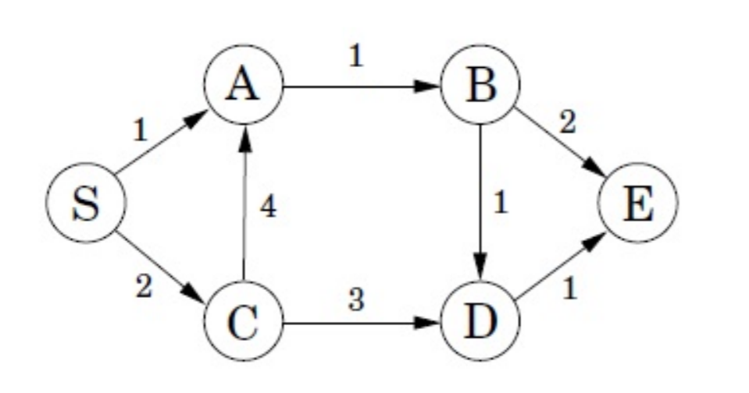 | L5 | CO3 | [5M]
 | b) | Write an algorithm to compute single source shortest paths for a graph using Greedy Method. | L1 | CO3 | [5M]
14. | a) | Solve the following 0/1 Knapsack Problem using dynamic programming n=4, m=30, (w1, w2, w3, w4) = (10, 15, 6, 9) and (p1, p2, p3, p4) = (2, 5, 8, 1). | L4 | CO4 | [5M]
 | b) | Write an algorithm to compute All pair’s shortest paths using dynamic programming approach. | L1 | CO4 | [5M]
15. | a) | Write the solution state space tree of 4-Queen’s | L1 | CO5 | [5M]
 | b) | Compute the shortest path of Travelling Sales Person (TSP) for the following graph by considering vertex “1” as source vertex using dynamic programming.  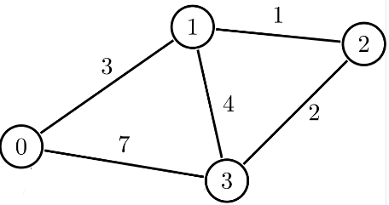 | L5 | CO5 | [5M]
16. | a) | Differentiate between deterministic and non-deterministic algorithm. | L3 | CO6 | [5M]
 | b) | Is the graph coloring NP-Complete problem? Justify your answer with an example. | L3 | CO6 | [5M]
17. | a) | Define algorithm and write the basic steps of pseudo code for representing an algorithm. | L1 | CO1 | [4M]
 | b) | Prove that the worst case time complexity of Binary Search is O(logn). | L4 | CO2 | [3M]
 | c) | Write the general method of Greedy Method. | L1 | CO3 | [3M]
18. | a) | Write the general method of dynamic programming. | L1 | CO4 | [4M]
 | b) | Write the applications of Branch and Bound technique. | L1 | CO5 | [3M]
 | c) | Is 3-SAT problem NP-Complete problem? Justify your answer. | L3 | CO6 | [3M]
-- 00 -- 00 –

